Marketing Strategy Plan
Name
Professor
Course
Date

Table of Contents
Marketing Strategy Plan 3
Why the Product: Introduction 3
Market Evolutions and Trends 4
Customer Behavior 7
SWOT 10
SWOT ANALYSIS 10
Difficult Elements: Success Factors 12
MARKETING STRATEGY 13
Mission 13
Objectives 13
STRATEGY SUMMARY 14
MARKETING MIX 15
Product 15
Distribution 17
Promotions 18
Pricing 19
SUMMARY AND RECOMMENDATION 20

Marketing Strategy Plan

Why the Product: Introduction
For an organization that seeks to be the "world's driving nourishment, and health organization", Yogcup uncovers an astonishing gap in the health portion in the U.S yogurt market. Today consumers are searching for products lined up with a sound way of life while keeping up taste and delight. Nutraceutical food industry is developing as health consciousness rises, particularly on the dairy segment. Thusly, it is pivotal for Yogcup to position itself in the quickest developing segment in the market, to be progressively lined up with its corporate mission and increment its piece of the pie in the yogurt classification.
Entering on the health segment, Yogcup should exploit its internal qualities and innovation accomplishments, and in accordance with the new market patterns and client needs, expand its low fat yogurt mark, Fatlessez, to grasp the dispatch of another product, Fatlessez, a fat free nutraceutical yogurt that gives two diverse medical advantages: boost the fat consume digestion and give a more grounded bone condition.
Advancing this idea will profit Yogcup's general position in the market since these advantages can pull in a significant potential market thinking about that an expansive number of the U.S populace experiences rheumatic and bone related diseases and the greater part is overweight. In addition, this health idea was not investigated before by any of its rivals.
Fatlessez will be focused to dynamic urban ladies, who esteem a yogurt that can assist them with controlling weight and keep up solid and sound bones through their lives. This Marketing Plan fits with Yogcup's corporate mission in conveying a sound and adjusted product, while elevating a health way of life to its clients.
The Plan starts by uncovering a profound class investigation, concentrated available patterns and client conduct, and furthermore on the key players on the business. The marketing strategy for this new product is portrayed and the distinctive marketing components nitty gritty, trailed by a money related investigation to exhibit the suitability of the arrangement. Finally, the execution plan and controls are displayed, just as a concise emergency course of action.
This Plan will use Nielsen's quantitative and subjective reports about the classification, particular market articles, as likewise hypothetical promoting writing.

Market Evolutions and Trends
Yogurt makers are launching each day inventive products to satisfy the latest consumers' needs and needs. Changes in working examples and way of life, and in frames of mind to life itself, have likewise prompted new customer needs.
The utilitarian and nutraceuticals yogurt market in U.S.A is developing relentlessly as purchasers turned out to be more health conscious. U.S purchasers are appearing developing worry with health matters, so they look for nourishment products related with prosperity, with yogurts saw as a wellspring of solid and regular food. These products are viewed as tenable, characteristic and even utilized as intends to battle diseases, for example, cholesterol or hypertension. Inside the health food market, consumers are moving far from products that lessen or kill undesirable fixings, for example, "light" or "low in fat" products, to products that have additional medical advantages, for example, utilitarian and sustained nourishments. As populace ages and social insurance costs rise, the pattern of expanding health cognizance is relied upon to proceed with, in this manner driving the interest for practical food products. It is normal that makers will proceed to create and present new practical and sustained fixings into their conventional product contributions, just as grow new products to address explicit health concerns (Andy)
To expand utilization events and in this manner drive product deals, makers are creating and testing diverse bundle configurations to advance yogurt utilization from at-home utilization to a functional throughout the day nibble, Euromonitor said (Adwan, 2003). Consumers need to have the capacity to purchase and eat food anyplace, whenever. A few instances of increasingly helpful configurations are yogurts with dispensable plastic spoons, or in squeezable cylinders. Other differentiating pattern has been to deliver more extravagance, creamier or outlandish varieties, such cheesecake or stracciatella flavors, situating these yogurts as pastry alternatives (Adwan, 2003).
As indicated by Nielsen 2007 Homescan information, all things considered, consumers acquired more decreased fat and entire milk than they did some other liquid ounce dairy products (Table 1). Among dry-ounce products, refrigerated yogurt is the one most bought, trailed by margarine and handled and regular cheese.
Dairy uses are biggest for diminished fat milk and mass frozen yogurt, which represent very nearly 42 percent of all out dairy consumptions. Regular cheese had the most astounding normal cost among the seven dry-ounce products, while drinkable yogurt had the most elevated normal cost among the six liquid ounce products.

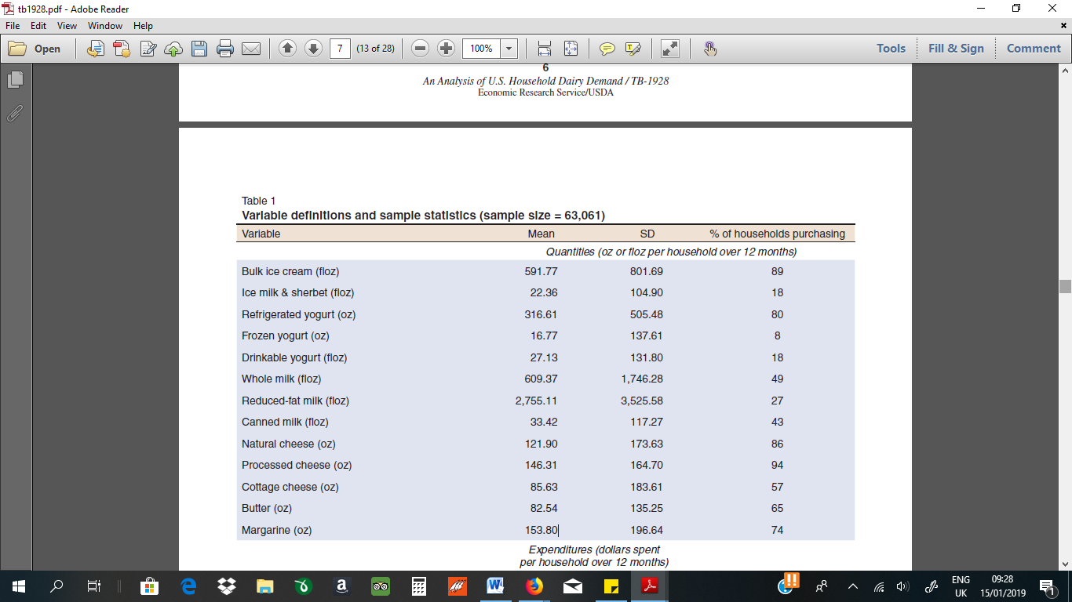
Source: Davis et al, 2010.
An a valid example is the Nielsen's study about chilled dairy products in U.S.A states that low fat yogurts, in spite of the reality of its utilization is somewhat diminishing, will keep on developing later on, since individuals are always worried about their looks and weight. These customers expect that the segment will keep on having an ever increasing number of varieties and flavors covering all brands and with other medical advantages related, other than the straightforward advantage of being without fat.
Consumers additionally wish them to wind up progressively moderate, increasingly common and with less synthetic compounds. A similar report trusts that health yogurts will likewise proceed to develop and differentiate. It is normal that the health capacities will proceed to increment and cover other kind of necessities, for example, against skin maturing, hostile to cellulite, nervousness control, and so on (Neilsen, 2007).

Customer Behavior
With regards to dairy product like milk, cheese, butter and yogurt, worldwide respondents lean toward nearby brands (54%); in any case, customers' inclination for local brands is diminishing contrasted with 2016 in classes like dessert (31%), solidified meat and fish (29%) and solidified suppers (22%) (Neisen, 2017).
Given the significance of dairy in local cooking styles and societies, it's not amazing that purchasers incline toward nearby brands for their commitment to nearby tastes and inclinations. Customer inclination for nearby brands is significantly increasingly articulated in locales that have solid agrarian societies, for example, Europe (66%), Africa and the Middle East (73%) (Table 2).

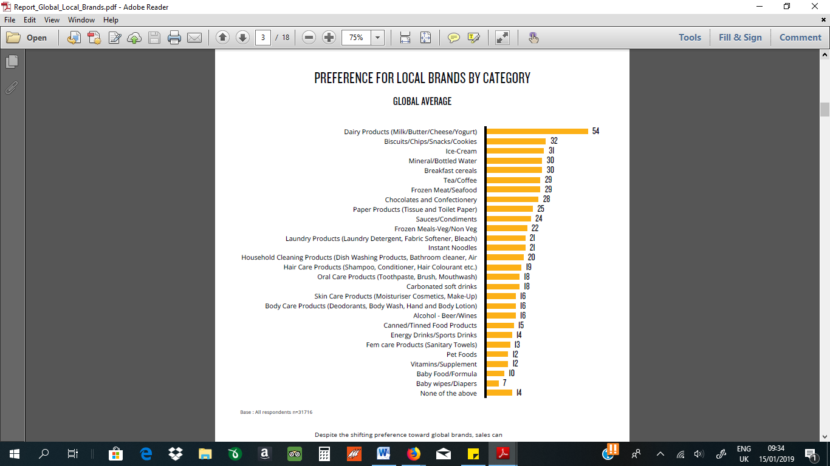
Source: Nielsen, 2017
As a low-involvement purchase, consumers will impossible pursue all the seven stages in the customer choice process display (Roger, 2006) when purchasing yogurts. It is impossible that the purchaser will start a procedure of data pursuit to decide mark attributes, nor is he liable to assess elective brands to recognize the most supported one (Henry, 2014). Rather, the customer gets data latently while sitting in front of the TV, perusing paper and magazines or when presented to different sorts of ad like in-store commercial. The buyer isn't generally assessing the advertising; he is simply observing the advertisement and putting away data. At that point, one day this purchaser while shopping will see the brand on the store retires and will connect it with the advertising topic. In the event that he framed a great supposition and on account of the nature that monotonous advertising produces, he will most likely try it out.
Accordingly, the obtaining procedure pursues fundamentally three principle steps. Consumers end up mindful of the product and frame convictions about it latently, at that point they settle on a purchase choice with little brand data and after that they assess the product after the purchase to decide the dimension of fulfilment. On the off chance that consumers are exceptionally fulfilled, rehashed purchase choices end up simpler.
As indicated by the purposes behind buying model (John, 2011)., customers when purchasing health yogurts pick products by execution criteria, principally auxiliary use capacity and accommodation, consumers pick products with nutraceutical benefits they are worried about, particularly in drinkable organizations that can be gone up against the go; by its inherent intrigue, similar to engaging quality of bundling or the sound of the brand name; by versatile reasons, similar to mark notoriety; by integrative criteria, nutraceuticals is a pattern on the nourishment market lastly, monetary criteria, if yogurts are estimated too lavishly they won't get it, they go for the ordinary one or the least expensive of the standard brands, price quality connection is constantly considered since these products are more costly than typical ones. After preliminary purchase, consumers pick without choosing, picking the last utilized brand in the event that it was acceptable, transforming it into a propensity. More often than not, health yogurt consumers are loyal to a brand or a kind of advantage since there aren't numerous choices in the market.
For the most part, yogurts purchasers expend them consistently. A purchaser's subjective study (Neisen, 2007) demonstrated that numerous customers ordinarily eat 2 or 3 yogurts every day, eating early in the day and mid-evening or at breakfast. There is likewise an impressive gathering that eats 1 every day at breakfast or eating toward the finish of the evening, while arriving home or after supper as a sweet or a late night nibble. Once in a while, a few ladies will even achieve 4 yogurts utilization daily, every now and again eating for the duration of the day, maintaining a strategic distance from enormous dinners or lunch, with a soup and organic product. In spite of this significant pattern, there are additionally a few consumers that devour yogurt 3 or 4 times each week, as a rule, not more than one every day. In the study, results demonstrate that the greater part of ladies will in general eat 1 or 2 yogurts per day, while men commonly devour them much of the time, yet under 1 per day or only 1 every day.
As indicated by the explanations behind purchasing model (Henry, 2004), consumers when purchasing health yogurts pick products by execution criteria, for the most part subordinate use capacity and comfort, consumers pick products with nutraceutical benefits they are worried about, particularly in drinkable arrangements that can be gone up against the go; by its inherent intrigue, similar to appeal of bundling or the sound of the brand name; by versatile reasons, similar to mark notoriety; by integrative criteria, nutraceuticals is a pattern on the nourishment market lastly, monetary criteria, if yogurts are evaluated too lavishly they won't get it, they go for the typical one or the least expensive of the standard brands, price quality connection is constantly considered since these products are more costly than ordinary ones. After preliminary purchase, customers pick without choosing, picking the last utilized brand on the off chance that it was agreeable, transforming it into a propensity. Ordinarily, health yogurt consumers are loyal to a brand or a sort of advantage since there aren't numerous options in the market.

SWOT

SWOT ANALYSIS
Now it is vital to build up a vital evaluation of qualities and shortcomings, openings and dangers of stretching out Fatlessez brand to grasp another utilitarian yogurt under its line of low fat yogurts. The SWOT investigation as pursues:

Strengths | Weaknesses
- Pioneer in the youngsters segment, and well  - situated in the low fat and grown-up beverages  - Worldwide dispatches of new promotions and redesigns of their real portfolio  - Perceived as a customary, dependable, safe and great quality brand  - Industry-driving innovative work  - Global Focus  - Wide scope of products and world-class premium brand portfolio  - Geographic nearness through the world | - Weak presence in the health segment  - Lack of learning of Yogcup products with  - points of interest advantages or health advanced  - High cost contrasted and distribution brands  - Fatlessez name is weird and does not recommend the kind of product  - More unequivocally connected with youngster food and chocolate
Opportunities | Threats
- Nutraceutical industry develops as health consciousness rises  - The most sold yogurt subcategory, health, is the one that is developing more in 2007  - Drinking yogurts offer the most ideal path forward  - U.S ladies are overwhelming purchasers of health and dietetic yogurts  - People with higher salary will in general search for additional extravagance or separated products  - Many Americans experiences rheumatic diseases  - Many of Americans are overweight | - Constant presentation of product developments in the distinctive segments by contenders  - Power of private names, representing 29% of the market with enhanced and less expensive contributions  - Retailers limitations on having new product lines, particularly in the event that they have possess private brands  - Sales of low fat products somewhat diminished  - Occasion use designs contrast from one portion to another  - Health related products are priced significantly higher than others in the classification and its communication is focus to increasingly advanced what's more, educated customers

From the investigation above, plainly nutraceuticals is a the present pattern in the market. Consumers are searching for products lined up with health and feel, particularly in helpful configurations that can be taken all over the place. Yogcup expects to be a nourishment and health organization, and accomplished numerous significant promotions in yogurt creation, and has capacities and assets to build its worldwide position in the classification by entering in the health segment with an imaginative medical advantage, satisfying a hole in the market with an product that anticipates medical issues that are rising today on society.

Difficult Elements: Success Factors
a. Convincing consumers of nutraceuticals adequacy: Manufacturers must create products with obvious medical advantages or else they will never influence consumers to grasp this costly idea of food.
b. Retailers' capacity and new products presentation: New product presentation charges, rack space stipends and retailer's edge ought to be considered, since they could be amazingly high if the retailers see the significance of the product to the maker.
c. Communicating new segment entrance through brand expansion: Yogcup isn't generally connected with products with explicit advantages or enhanced, in spite of its food claims, in U.S.A it isn't spoken to in health dairy products. The passage on the segment trough a brand expansion of Fatlessez brand ought to be vigorously imparted in an unmistakably reasonable manner.
d. Achieving circulation in a sensible time span: The dispatch will be absolutely inadequate if the product isn't accessible in all grocery store and hypermarket retires across the country, as additionally on the most frequented urban cafeterias and candy machines in a sensible timeframe.

MARKETING STRATEGY

Mission
In Yogcup's vision, food has entered another time, these days consumers are searching for something more, an enhanced healthy benefit. Yogcup tries to give consumers the products they requirement for a sound life. It empowers a fair, solid eating regimen and fabricates products that fit into it, investing in increment the healthy benefit of its products while enhancing taste and delight. Fatlessez fits superbly on the corporate mission, conveying a solid and adjusted product enabling purchasers to appreciate a health life.

Objectives
Fatlessez's primary objective is to set up a dependable Yogcup brand on the health segment in the U.S yogurt market. Taking into account that a definitive marketing objective for each organization is to amplify benefit, in this manner deals (outright volume) and subsequently piece of the pie (relative volume in the class) objectives will be set for the underlying dispatch time frame and past, since health is a developing business sector segment in U.S.A and we are launching another product in the market.
Today, Yogcup has 0.89% piece of the overall industry on the health segment. The objective is to achieve 1% piece of the pie on the principal year, 1.5% on the second and 1.89% on the third year. Consequently, if the objective is to accomplish 1% share in its first year, and expecting the market will keep on developing at a similar rate.

STRATEGY SUMMARY
Characterizing advertising strategy includes two key exercises: "choosing an objective market and deciding the ideal situating of the product in the objective client's brains; and indicating the arrangement for the ideal exercises to achieve the ideal situating" (Dolan, 2000). Intending to set up a solid product in the health segment, and furthermore increment its offer on the yogurt market when all is said in done, Yogcup ought to pursue an product advancement strategy, by launching another product on a class it as of now contends in (Keller, 2007).
Yogcup will create Fatlessez, a fat free drinkable yogurt, enhanced with additional calcium and nutrient D, ready to augment fat consume digestion and construct solid and sound bones. This yogurt will be launched through a Fatlessez mark augmentation.
Fatlessez will be focused to dynamic health conscious ladies that more often than not destroy from home and anticipate from a yogurt the health supplement they require. The product will be low in calories and 0% fat yogurt ready to augment fat consume digestion and assemble solid bones because of calcium and nutrient D admissions. Cost will be characterized by considering normal market costs, product producing expenses and esteem conveyed to consumers, and it will be disseminated on stores, hypermarkets, limits, and little retailers. Communication will be founded on the two principle benefits: controlling weight and building solid bones, through TV advertising, purpose of-offer promotions, testing and some other explicit advancement and promoting apparatuses.

MARKETING MIX

Product
Researchers at the Yogcup Research Center will build up an equation that enables customers to maximize their fat digestion, while in the meantime invigorate their bones. Taken as a feature of a reasonable eating regimen and customary exercise, Fatlessez can help with weight the executives on account of its calcium content. Research demonstrates that calcium can assume an essential job in body weight direction and fat digestion. Stunningly better, by expanding admission of dairy calcium consumers might have the capacity to decrease future weight gain. Besides, satisfactory dietary calcium consumption joined with nutrient D is a standout amongst the most vital components contributing for solid bone structure. The most effective retention of calcium relies upon the nearness of nutrient D in the body, which is a key fixing in the different hormones that empower calcium to go from the stomach related framework into the blood or bones. Deficiency of calcium after some time may cause bone related diseases.
Fatlessez will be launched under the Fatlessez mark, in a line mark augmentation, since the new product will even now contend in the yogurt class, in another line, so as to decrease launching expenses and corporate issues, and most essential to profit by Fatlessez consciousness in the U.S market. Consumers often pursue versatile criteria, similar to mark notoriety, when purchasing yogurts.
Brands are among an organization's most significant resources, especially when the organization, as Yogcup, is dynamic in the purchaser merchandise industry. Accordingly, the estimation of a brand can't be founded simply on its deals, similarly essential, if not more along these lines, is its enthusiastic esteem. Today, Yogcup has just two sorts of brands, corporate brands and range/product brands, which can be utilized at all three dimensions – around the world, territorially and locally. As indicated by the brand relationship range (Aaker, 2004), Yogcup is an ace brand, under which the organization moves chocolates, dairy products, tyke food products, waters, and an assortment of different products. It appears to be certain that the dominating brand strategy Yogcup is utilizing is a corporate support system. Yogcup has accumulated a few products under a worldwide umbrella. This is sparing expenses for Yogcup in brand interchanges, yet it is likewise consoling for the customer when they realize that one product they like is identified with an product they don't know yet, however which they need to experiment with. They know the great quality the product speaks to. This empowered products under the Yogcup umbrella to profit by the notoriety and commonality of Yogcup, and the organization to profit by their fame.
Fatlessez is endorsed by Yogcup; an endorser mark is use to give validity and substance to the advertising. Supports are incredible in light of the fact that endorsers are to some degree protected from the brands they underwrite. Consequently, they can contribute with decreased hazard that their affiliations will be influenced by the execution of the embraced brand (Aaker, 2004).
As it was referenced previously, this yogurt will be marketed just on the drinkable arrangement, since the present buyer esteems in a hurry bites that can be taken whenever, anyplace.
Concerning flavors and varieties accessible, the choice was made dependent on two markers, first the most moving yogurt enhances in U.S.A, that are strawberry, peach, wild berry, pineapple, and tutti-frutti, and second, the review led for this task, where it was demonstrated that customers incline toward by request, strawberry, wild berry, banana, characteristic and mango.
Since creating more flavors will expand generation costs by utilizing distinctive crude materials, diverse bundling, and in the generation line itself, Fatlessez at first will be launched in strawberry, wild berry, banana and mango. By expanding flavors combination to fulfil consumers that look for assortment and to coordinate the most refreshing flavors by the objective market, it will likewise diminish dispersion costs by limiting posting expenses. Promotions and TV spots should center the new advertising.

Distribution
Fatlessez will possibly prevail in the market if the channels, as courses to the market, can react to the interest level expected for the product, by mulling over interest and supply-side components while going for a similar time to limit working expenses.
Fatlessez, as the other Yogcup yogurts popularized in U.S.A, will be created in plants situated in Spain and France, that serve likewise numerous other European markets. So as to be marketed, all yogurt clumps must be tried by examining. Yogurts are kept in the manufacturing plants for control testing for two days and after that are dispatched to the U.S circulation focuses. Transportation is redistributed to particular organizations in whole deal trucks.
Concerning structure and force, Fatlessez since it is a comfort product will pursue an escalated involvement strategy by being available in all stores with high deals volume, accomplishing an abnormal state of weighted conveyance. This arrangement is regular for Fatlessez products and is upheld on the way that quick moving customers products mark piece of the pie is lopsidedly identified with circulation involvement. After a specific dimension of involvement being come to, anchoring a couple of more purposes of circulation involvement reflects in a sharp development in piece of the pie. This happens in light of the fact that numerous customers won't abandon one store to visit another on the off chance that they can't locate their favored brands; they will all the more most likely purchase another brand. Little retailers much of the time just stock the main a couple of brands because of space requirements, realizing it will be adequate for the majority of their clients. Subsequently, involvement over a limit level lifts involvement in little outlets, which quickly supports a brand's offer excessively. The higher the brand's piece of the pie the more prominent the probability that other little stores will embrace the brand, expanding its offer.

Promotions
Target group choice and activity destinations: Target gathering of people choice (to whom the crusade is coordinated) and activity goals (what activity the battle ought to urge them to take) was the following stage in arranging product's communications.
From the potential market for Fatlessez, the best deals potential originates from other
brand loyal (OBLs), that will trade from different brands, particularly low fat and health brands, where it is conceivable to happen some savagery to other Yogcup yogurts like Fatlessez, and furthermore new category users (NCUs) that normally don't drink health or dietetic yogurts yet are worried about their bones health or muscle to fat ratio, and can be possibly inspired by Fatlessez benefits. The objective is to turn this forthcoming purchasers in brand loyal (BLs) speaking profoundly of offers or if nothing else good brand switchers (FBSs), by incorporating the brand in their collection.
Communication positioning and objectives: When arranging an explicit advertising communication or advancement crusade, communication goals must be chosen by chiefs. For Fatlessez launching effort the communication goals to reach are classification require, brand consciousness and brand attitude.
Brand purchase expectation was not chosen for the battle since it is a low-association brand decision, in this manner it is sensible to assume that an entirely good brand attitude is adequate to consequently invigorate brand purchase aim when the following purchase opportunity emerges. In-store improvements, for example, coupons, shows, or price arrangements ought to be utilized to invigorate brand purchase expectation when purchasers are uninvolved. Consumers may buy the brand at eye level or the one with the biggest rack space essentially in light of the update impact (Assael, 2007). Class require objective was chosen since we are building up another sort of product inside the health segment, and we need to make the need of an product that fulfills the two advantages of controlling weight and sustaining bone structure in planned purchaser's brains.
Brand consciousness and brand mentality are dependably communication impacts wanted in each communication battle. Potential customers of Fatlessez would need to take in the new product's name and to perceive the product on the general store retires, and should trust the product can give the advantages and frame a good supposition of the brand.

Pricing
Pricing ought to be in a state of harmony with the esteem creation procedure of alternate components of the advertising blend. A more expensive rate is possibly legitimized when a high interest in promoting exists. The product, including brand, highlights, benefit levels, dissemination and communication makes the esteem, price catches this esteem.
Yogcup will price its products consolidating three alternate points of view: commitment edge objective for the organization – cost based viewpoint, market normal costs – rivalry based, lastly, product esteem in customers' point of view – esteem based. Research methods can give a thought of the price that purchasers will pay for the product. For new products or new brands, Yogcup considers the three points of view and directs subjective and quantitative market tests to gauge the customers' acknowledgment and furthermore their purchasing intension.
Concerning price strategy, the thought is to put the product in the market as an esteemed included low fat product, in this manner higher evaluated than low fat, and yet not as costly as a health yogurt. Subsequently, the low fat cost will set up the floor and the health cost will set up the roof. In this manner, in view of the Nielsen deals board esteems (Nelsen, 2007), the method was to figure the normal retail cost per kg on the low fat and on the health segment (Table 3).
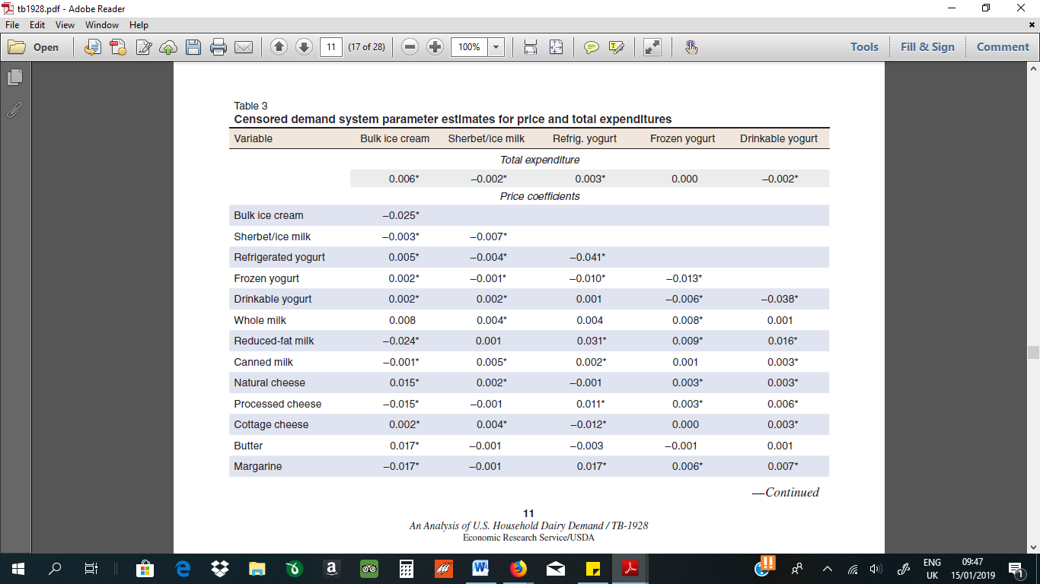
Source: Davis et al, 2010.

SUMMARY AND RECOMMENDATION
Fatlessez execution plan was produced for a sum of three years, and can be all inclusive partitioned into three particular stages, as characterized previously. The main stage will guarantee the best possible dispersion of the product before launching the media battle, following three weeks' time the second stage starts with a substantial media crusade, which keep going for two months. From that point, support media battles will be on air four times each year and the marketing spotlight will be on customer promotions. The execution plan requires the coordination of the Marketing, Sales and Logistics groups.
As far as control, it is important to quantify the accomplishment of piece of the overall industry and deals income goals ceaselessly, as the prior the assessment more chances to adjust the arrangement exist and increment the odds of achievement. Additionally communication targets achievement ought to be assed. As the arrangement is being executed, casual gatherings with the general population doing the arrangement ought to be done, just as increasingly thorough formal methods for social event information from deals groups, buyer gatherings and different organizations.
The data accumulated in this procedure will show how far we are from the characterized targets and on the off chance that economic situations contrasted altogether from the anticipated, an emergency course of action must be created.
There is some plausibility of not accomplishing adequate dispersion in a sensible time allotment, provided that this is true, preliminary promotions should increment to 3% in the main year, and 2% on the next years; and furthermore the interest in marked stock endowments ought to be multiplied. On the off chance that business objective have all the earmarks of being a long way from anticipated, another inspecting action must be executed a half year after and more exertion will be put on customer promotions.
Trade promotions have a critical job since the start to guarantee adequate involvement for promoting to work. A maker's buyer oriented advertising and advancement is probably going to come up short except if trade promotions have prevailing with regards to inducing channel mediators to stock satisfactory amounts. Trade stipends are utilized to remunerate retailers for performing exercises in help of the maker's image. These recompenses urge retailers to stock the producer's image, markdown the brand's cost to customers, highlight it in promoting, or give uncommon market or other purpose of-procurement bolster, yet additionally to acquire positive rack space. Numerous retailers get a settled off-receipt recompense going up, contingent upon the retailer's power. Other trade promotions activities will be actualized as seen from above.

References
Adwan, L. (2003). What ……………………………………….Yoghurt Growth? Euromonitor.
David A. Aaker, D. (2004). ……………………………………. Strategy. Free Press.
Davis, C., Dong, D., Blayney, D. & Owens, A. (2010). An …………………………………….Dairy Demand, TB-1928, U.S. ept. of Agr., Econ. Res. Serv. Retrieved from: https://ageconsearch. ……………………………………./184308/2/tb1928.pdf
Dolan, R. (2000). "Note on Marketing …………………………………….Business School, 2000. Case No. 9-598-061
Henry. A. (2004). “Consumer Behaviour, A Strategic approach”, Houghton Mifflin Company,
Keller, K. (2007). Strategic Brand ……………………………………., Upper Saddle River, New Jersey.
Nielsen. (2007). Homescan Retail Purchase Data.
Nielsen. (2017). “Made in” Matters…………………………………….Nielsen Company (US), LLC. Retrieved from: https://www.nielsen.com/content/…………………………………….Global_Local_Brands.pdf

